Final Project Design Phase
Computer Science - Week 11
Oct 3, 2026 - Version 0.0.4

For complete instructions and project ideas, refer to the assignment in Canvas. Specifically, review the final project requirements before you continue below. If you have not reviewed the project requirements in Canvas (you might have to go to the modules view and check the current or past week's content), you will not be able to properly complete the parts below. In addition, it may be helpful to review the information on this Drafter documentation page.

0) Project Planning and Preparation
Successful programmers spend time planning before they begin coding. After reviewing the project requirements, answer the following questions to help guide your design and development process.
- What concepts from class or previous assignments might help you complete this project? Which programming concepts (loops, conditionals, lists, classes, etc.) do you expect to use? What programming skills do you want to improve while completing this project?
I think the previous projects we’ve done so far will help be a guideline as to how to break up my program into manageable helper functions. In regards to programming concepts, I will definitely be using loops, lists, conditionals, and classes. I also think I’ll be working with files for the assignment, which is an area I need to improve on. I also would like to get more comfortable overall with drafter, and with managing my time for a bigger project.

- Which parts of the project do you expect to be the easiest for you? The hardest? Why?
I think setting up the different routes and going from page to page will be relatively easy once I get comfortable with drafter syntax. I believe that implementing my audio playback features and the actual staff that composers can use may be quite hard because while I have experience implementing audio in game engines, I don’t have much experience using audio in raw python or drafter.

- Even though you have not yet designed the final project, estimate which tasks will likely require the most time and effort? Which features or components should be implemented first?
First, I should implement the general ‘skeleton’ of my site, which would include my pages and the routes to get to each page. Everything else needs the skeleton to function, and it would be a relatively easy thing to implement and use to get comfortable with drafter syntax.

- What distractions might interfere with your work and how will you minimize them? What resources will you need available while working? What questions, if any, do you still have about the assignment requirements?

1) Site Diagram
Create a mock-up of your planned website. We suggest you make the mockup on paper, although you can also use software like PowerPoint or Slides to make a mockup. There is other design software that could also be used, but we strongly encourage you to keep it simple. Do not spend more than 15-30 minutes detailing the mock-up. Your goal should be to make a very quick and dirty diagram, to show that you have some kind of idea.

We recommend drawing each page as a rectangle, and laying out the text, buttons, and other components inside. Then, use arrows to indicate links between pages. Label each page the way you will name each function, and then put labels on the arrows to indicate what the button links. Also write down any parameters that should come into the pages.

In addition to the pages and routes, write down what fields your `State` will have, both their names and types. Think clearly about what data will need to be persistent across the entire website.

Add photo(s) or screenshot(s) of your website mock-up and labeled diagram on the next page.

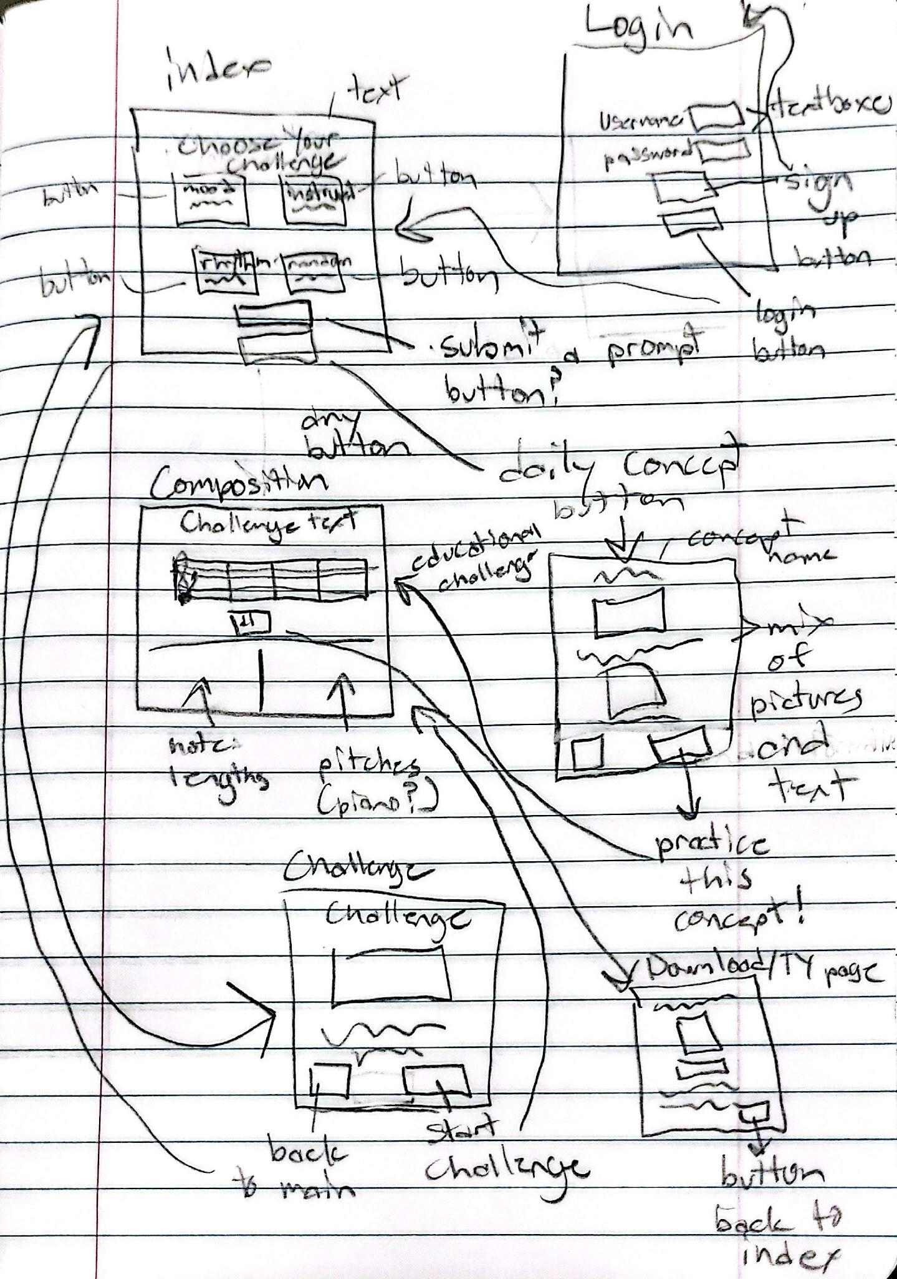

2) Implementing Requirements
This table should serve as a draft for how you will implement the requirements into your final project. You may change your ideas later on, but your final site must fulfill all the requirements.

Requirement | Implementation
Purpose/Functionality  A 1-2 sentence description of the purpose or functionality of your site | My site will encourage people to compose music by being a short daily composition challenge, in a similar vein to Wordle. The site would have different challenges and the ability to display and playback a user’s composition on a staff.
State Dataclass Attributes  Minimum of 4 attributes, one of which must be a list/dict of instances of your second dataclass.  Briefly describe each attribute, its type, and how it will be meaningfully modified throughout the site. | Measure:  Size: (int) how many beats in the measure  Time signature: (int) determines what 1 beat is in the music  Notes: (list[Note]) holds the notes/rests that the user has put into a measure  Key: alters specific notes based on what key signature the music is in
Second Dataclass  Your second dataclass, including its attributes, their types, and how they will be meaningfully modified (if they are modified) | Note  Length: (int) how long a note plays for  Pitch: (str) what pitch the note is played at, will be modified if the user moves the note up or down on the staff
Routes (minimum 7)

The names of your route functions
Pages (minimum 5)  A brief description of the pages in your site | Login: page to login or potentially sign up to the site  Index/Main: page with a list of challenge categories for composers to choose from  Challenge: page that explains the daily challenge the user choose  Composition: page where users write their music  Thanks: page that pops up after you download your music  Education: page where users can go to learn about a daily music theory concept
User Input (minimum 3)  Description of user input components (TextBox, TextArea, CheckBox, or SelectBox) and their purposes  For more information on these input types, see Drafter Documentation. | TextBox x2: Username and Password fields for login  SelectBox: gives options for what note length the user wants to be placing  CheckBox: switches the notes the user will place into rests
If Statements (minimum 3)  Brief description of what will be evaluated in your if statements and how they will meaningfully change the logic of the site | Login if statement: if username and password equals what the user entered login, otherwise return error message  Challenge if statement: checks what type of challenge the user selected and fills out the challenge page accordingly  Note if statements: checks for a variety of note properties during composition playback, including:  - Pitch  - If it’s a rest
Loop (minimum 1)  This loop must iterate over the list/dict of dataclass instances in your State attribute.  Description of this loop and why it is meaningful to the site | For composition playback, I will have a loop that iterates over each note in each measure, checking their properties and playing them accordingly. This will be the main function of the site.

LLM Conversation
If you used an LLM in any part of this work, copy and paste every part of that conversation below. Otherwise, you may be given a zero for the assignment. Obviously, these words will not all be yours, and this is the exception to the requirement at the top of this assignment that all responses be in your own words. If you did not use an LLM to assist you in this assignment, simply say so below.
Replace this text with your answer.

Final Submission
When you are finished, download this file as a Word Document (docx) and upload the file to the appropriate assignment on Canvas.

